



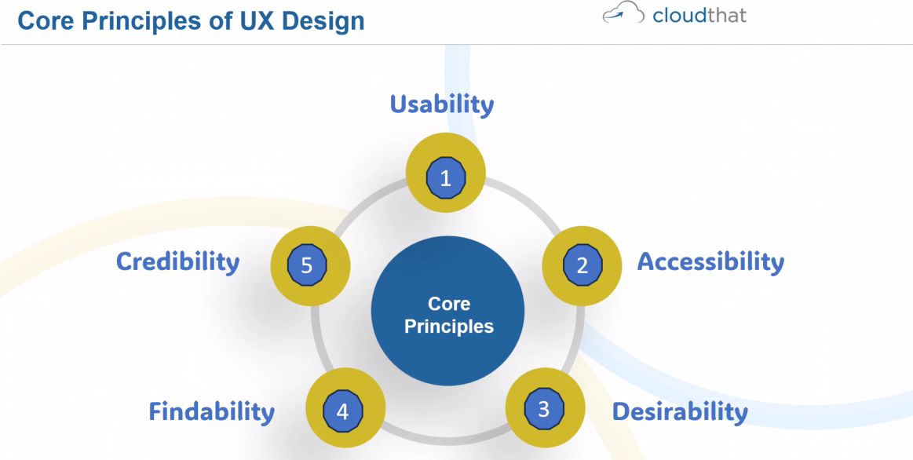



Colorhunt.co – website

<https://colorhunt.co/>



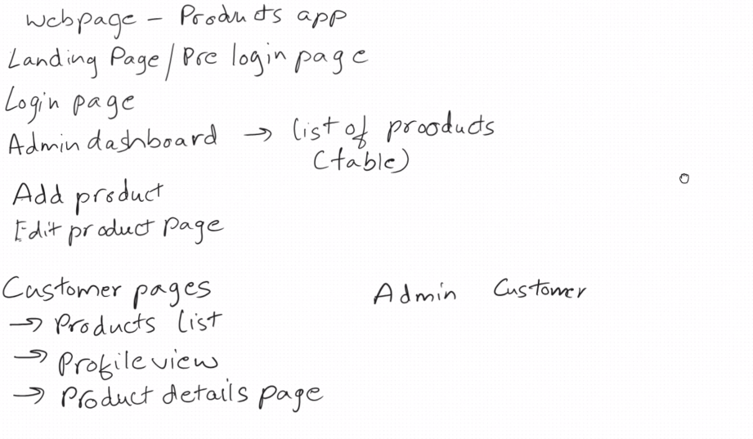

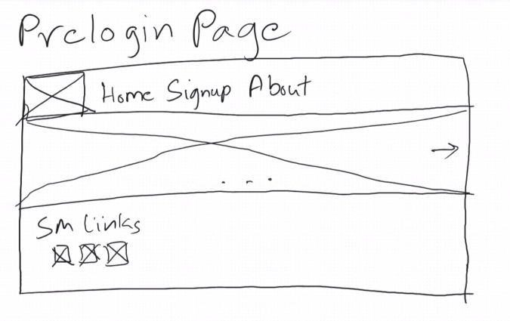

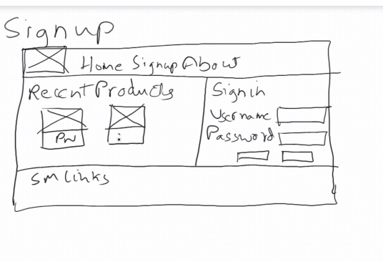

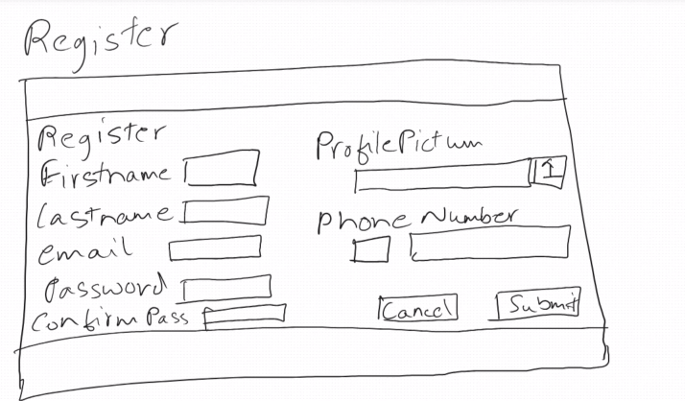

Sign-in

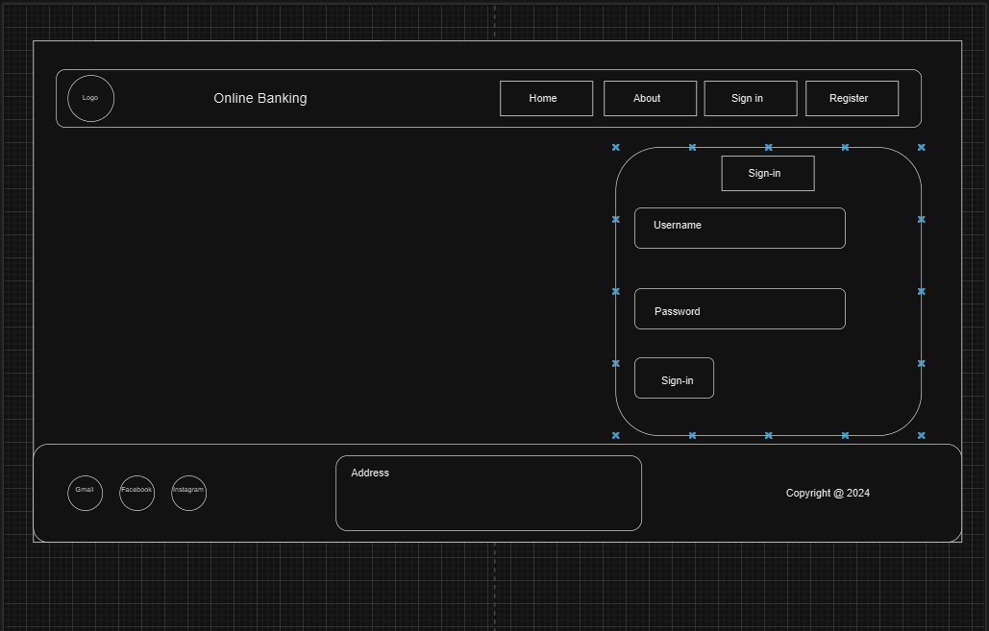

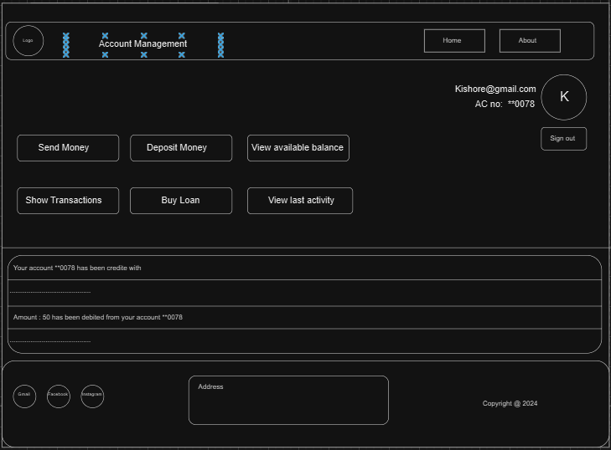

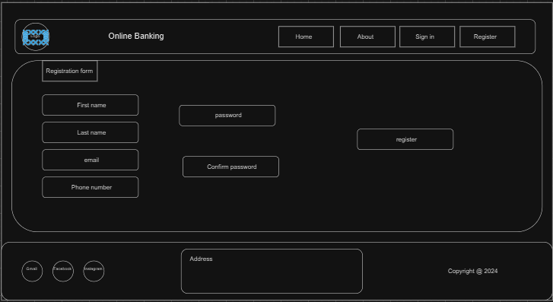

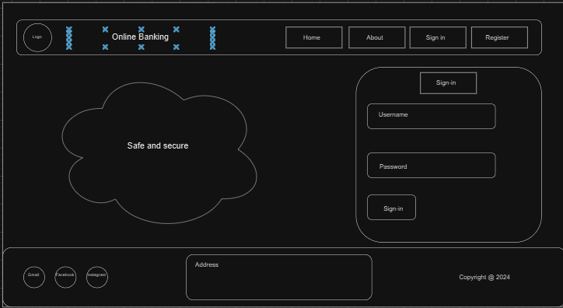

<https://lawsofux.com/>

<https://uxhints.com/>

https://a.co/d/j7fLURg

<https://a.co/d/duakmG0>

<https://method.ac/>

<https://refero.design/>

<https://sharpen.design/>

<https://growth.design/>

<https://www.figma.com> important tool

<https://css-tricks.com/snippets/css/a-guide-to-flexbox/>

<https://css-tricks.com/snippets/css/complete-guide-grid/>

[vishwas@cloudthat.com](mailto:vishwas@cloudthat.com) viswas email link